Project Overview
Application Name
Name | PGSO - Warehouse Inventory and Management System (PGSO-WIMS)
Description | Warehouse Inventory & Stock Monitoring System (WISMS) is a networked web-based application designed to streamline the tracking and management of office and janitorial supply inventories. It provides an efficient and organized platform for real-time stock monitoring, ensuring accurate inventory control and optimized resource management across warehouse operations.  1. Consolidation of the Project Procurement Management Plans (PPMP) from the various offices within the Provincial Government of Benguet.  2. Facilitates the generation of Purchase Requests and tracking of unpurchased items listed in the Annual Procurement Plan (Consolidated PPMP).  3. Receive Items with automatic stock updates.  4. Issuance of items to various offices based on the submitted PPMP with automatic stock updates.  5. Monitoring of items that are either nearing their expiration dates or have reached the minimum stock threshold set for reordering.  6. Generate reports such as Office and Janitorial Supplies Inventory Report, Stock Card, Summary of Supplies & Materials Issued and etc.
Version | 1.0.0
Repository | https://github.com/sudo-InsideOut/WarePro.v2.git

Tech Stack
Category | Technology
Backend | Laravel 11
Monolith | Inertia JS
Frontend | Vue 3
Database | MySQL
CSS Framework | Tailwind
Build Tool | Vite
Deployment | local server
IP Address | 192.168.2.18/WarePro.v2

2. Development Setup
Prerequisites | PHP ≥ 8.2  Node.js ≥ v22.14.0  Composer ≥ 2.8.6  MySQL

INSTALLATION
#Clone the repository
gh repo clone sudo-InsideOut/WarePro.v2
#Bash
git clone https://github.com/sudo-InsideOut/WarePro.v2.git
#CLI
cd WarePro.v2
composer install
npm install
Go to this directory C:\xampp\htdocs\WarePro.v2\zinstallation
Copy the tcpdf_config.php file
Paste it on this directory C:\xampp\htdocs\WarePro.v2\vendor\tecnickcom\tcpdf\config
Copy .env.example to .env
php artisan key:generate
##For New Database only
Run migrations & seeders
php artisan migrate --seed
#For development:
npm run dev
#For production:
npm run build

Database Back Up and Inventory Reset
Run schedule.bat file automatic
1.Open task scheduler
2.Create Task
3. Follow the Sample Setup Below
4. Click “OK”
#Sample Setup
GENERAL
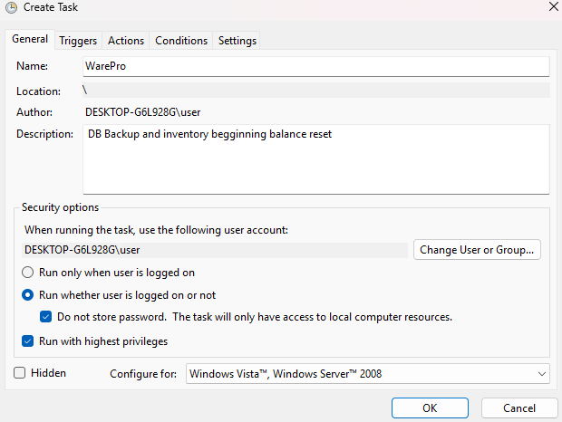
NEW TRIGGER
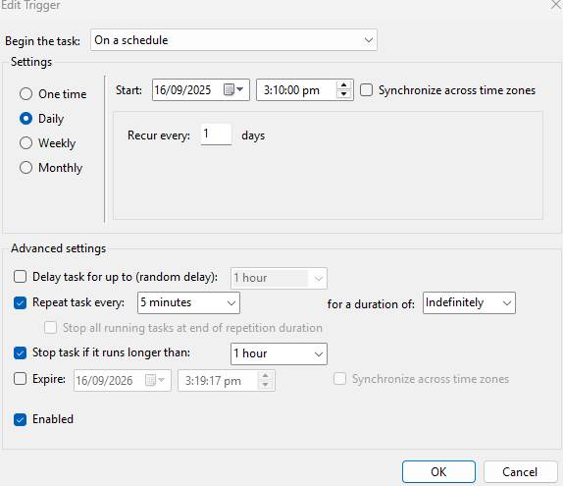
NEW ACTION
